INTRODUCTION TO OSCILLOSCOPE

INTRODUCTION :

Oscilloscopes are tools that allow engineers to view signals graphically. The oscilloscope, often just called the scope, displays the signals as a plot of magnitude versus time.

There are two types of oscilloscopes: analog and digital. Analog oscilloscopes use a cathode ray tube and display the signal much like a television set displays an image. Digital oscilloscopes sample the signals digitally and are more flexible in how they display, manipulate, and store the signals.

The oscilloscope can be adjusted so that repetitive signals can be observed as a continuous shape on the screen. A storage oscilloscope allows single events to be captured by the instrument and displayed for a relatively long time, allowing human observation of events too fast to be directly perceptible.

Oscilloscopes are used in the sciences, medicine, engineering, and telecommunications industry. General-purpose instruments are used for maintenance of electronic equipment and laboratory work. Special-purpose oscilloscopes may be used for such purposes as analyzing an automotive ignition system or to display the waveform of the heartbeat as an [electrocardiogram](http://en.wikipedia.org/wiki/Electrocardiogram).

TURNING ON THE OSCILLOSCOPE

To turn on the oscilloscope, press the power on button on the lower left-hand side of the oscilloscope. Shortly afterwards, you will see a boot screen, and then a start up screen. Press the MENU OFF button to proceed.

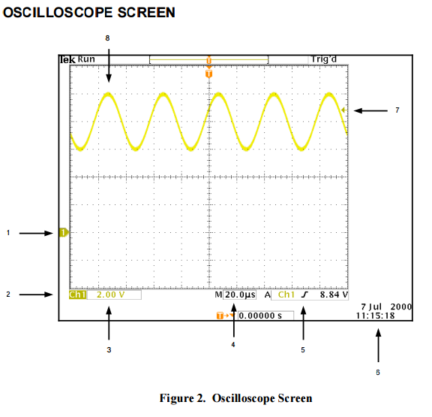

Figure 2 depicts the typical oscilloscope screen. The elements of the screen are as follows: 1. Waveform baseline icon. Shows the zero volt level of the waveform. 2. Channel indicator. 3. Channel scale factor. 4. Time per division. 5. Trigger slope. 6. Date and time. 7. Trigger level icon. 8. Visual representation of waveform.

OSCILLOSCOPE SETTINGS

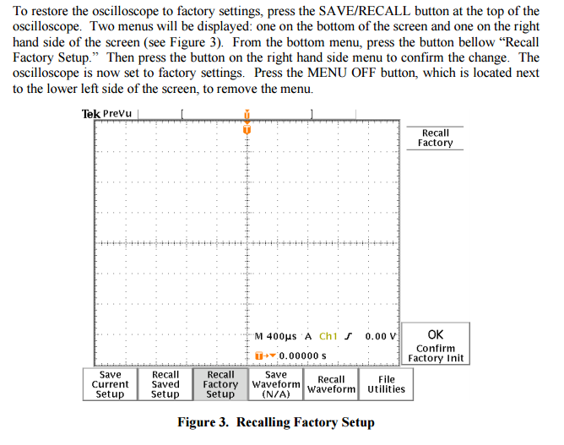

**SCREEN MEASUREMENTS**

The oscilloscope can be used to measure the different properties of signals. In this section you will learn how to use the oscilloscope to measure the amplitude, frequency and period of a signal. The signal that you measure will be the default signal supplied by the arbitrary/functiongenerator.Turn on the arbitrary/function generator. Use a BNC to BNC cable to connect output 1 of the function generator to channel 1 of the oscilloscope. Turn On the Output of Channel 1 of the

function generator. On the screen of the oscilloscope you should see a yellow “fuzz.” Press the

AUTOSET button on the oscilloscope. After a second or two you should see a sine wave.

**MEASURING AMPLITUDE**

The arbitrary/function generator expects a 50  terminal load. With a load significantly larger than 50 , the function generator will supply double the voltage it is set to. That is why the oscilloscope has a sine wave with amplitude of 1 V, or a peak to peak voltage of 2 V. There are two ways to fix this:

1. With a BNC T connector, connect a 50  terminal load to the input of the oscilloscope.

2. Set the oscilloscope to internal impedance of 50 .On the oscilloscope, between the channel 1 and 2 terminals, and slightly above, press the MENU

button. This menu button brings up the menu for channel settings. On the bottom of the right hand menu you will see the omega symbol (). Pressing this button toggles the input impedance between 1 M and 50 .

MEASURING FREQUENCY AND PERIOD

